Matthew Fish

Matthew.Fish@students.plymouth.ac.uk

BSc(hons) Computer Science 2024



Future Development

Core Features

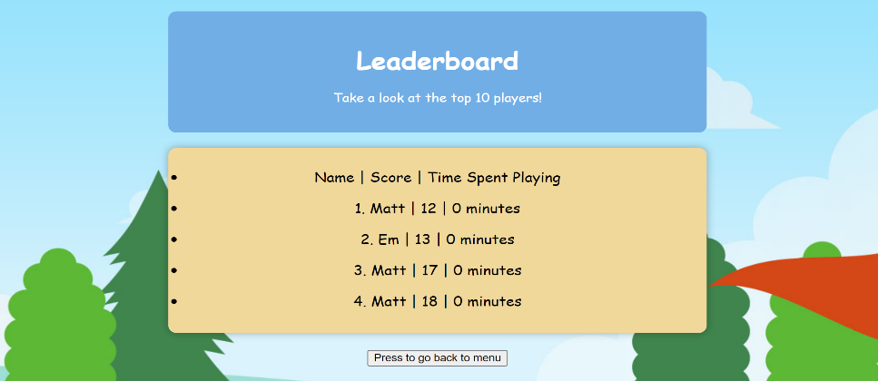

* Classic Aesthetics, Modern Gameplay: Enjoy the Nostalgia of retro graphics whilst experiencing smooth gameplay.
* Ball Dragging Mechanics: Experience intuitive controls with a unique ball-dragging mechanic, allowing players to precisely aim their shots and adjust power with ease.
* Randomly Placed Obstacles: Navigate through sand, water and wall hazards randomly placed across each hole, ensuring a fresh and unpredictable challenge.
* Customize Ball Colour: Personalize your gameplay experience by choosing from a range of colours, adding a touch of customization to your rounds.
* Integrated Leaderboard: Keep track of your minutes spent playing and compare your scores against friends. Input your name to see your scores displayed amongst the top players!
* Immersive Sound Effects: Immerse yourself in a golf atmosphere with nature inspired sound effects. Hear the satisfying thud of the golf ball as its struck, adding authenticity to your golfing experience.

**Retro Golf**

Tee off into nostalgia!

Retro Golf invites players to embark on a nostalgic journey through 9 unique and exciting holes of golf.

With an integrated leaderboard, players can track their progress and compete against other players to gather the lowest scores and secure the top spot.

Inspiration for this game has come from classics like Raft Wars and 8 Ball Pool.

Game Overview

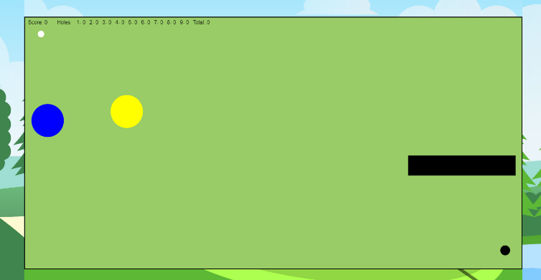

Step into the nostalgic world of Retro Golf, where classic gameplay meets golf.